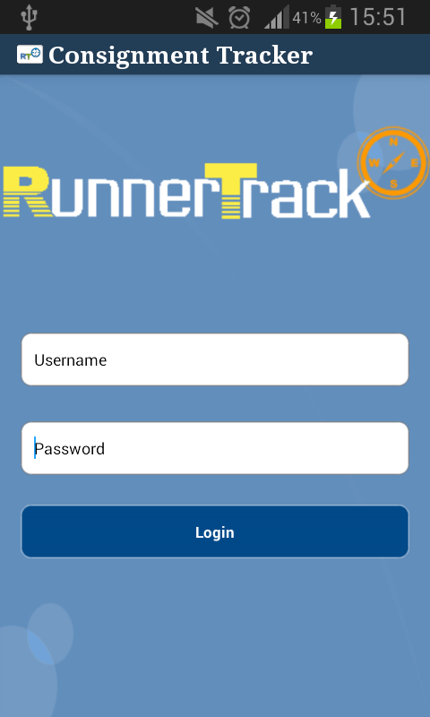
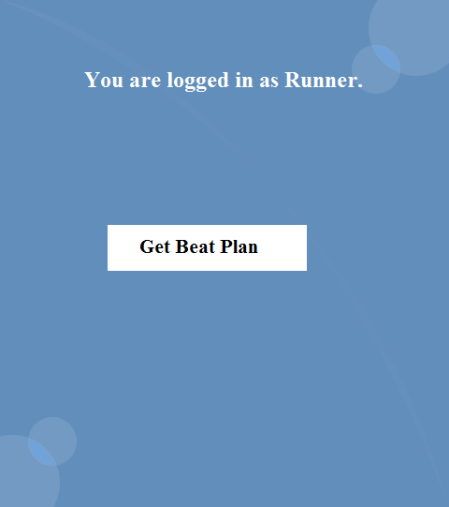
Runner Flow:

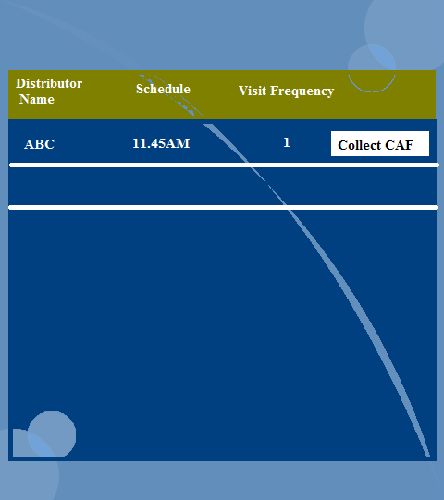

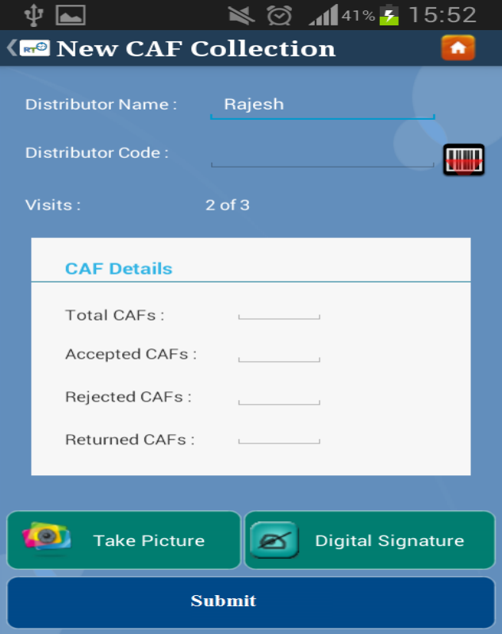
123456786789

In the Backend the code which is scanned is validated with the existing code.
Team Leader Flow:

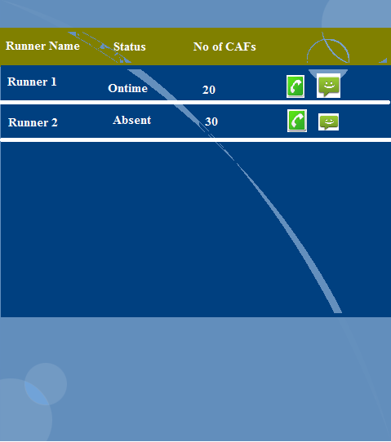

123456865
In the Backend the code which is scanned is validated with the existing code.

Functionalities:

- After launching the App, we need to check for the GPS and GPRS availability, if any of the one is not enabled, we have to enable them automatically.
- User sends request for login providing mobile number and password to Server. If the login is success the response is provided with AuthId and required details corresponding to User.
- After that every request has to made to the server providing AuthId which we get when user is logged in.
- Every 10 minutes the app should send latitude and longitude along with AuthId to the server.
- When the Battery status is below 20% , then the Message should be sent to Team Leader regarding the battery status of User.
- New CAF has to submitted to server by checking the network availability, if the network is not available we have to save the CAF details in the local database, whenever the network is available we need to send back all the CAF details to the server and delete the data in the database.
- Image Size of Digital Signature and Capture Photo should be minimized to a particular size, in order to decrease the message size which has to be sent to the server.
- When ever the server send the notification regarding the log out of app, we need to log out the app along with disabling GPS and GPRS and deleting the AuthId from the Application.

